Subject

Computer Vision
Activities in class
Unit I
Digital Image Fundamentals
Session 02

Teacher: Rubén Ferreiroa

- Exercise: Convolution Implementation
Consider a 6×6 input image:
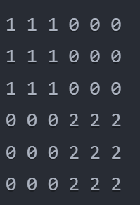
And a 2×2 kernel:

Perform the following tasks:
- Apply the convolution with:
- Stride = 2
- No padding
- Show the complete output matrix
- Explain how the stride affects:
- The output size
- The receptive field
- The amount of information preserved from the original image
For full credit:
Show all calculations
Explain the effect of stride on feature detection
Discuss what information is lost or preserved with the given stride
Manual and Python implementation

